Analysis of Wharf Park Project based on placeness

Ma DongQing, Yoon JiYoung

Dept of environment contents
Graduate School of Dong-Seo University
Busan, South Korea
260033675@QQ.com, klismos@gdsu.dongseo.ac.kr

Abstract

This paper takes the site design of urban waterfront landscape environment as the research objective. First of all, summarize the characteristics of the landscape through theoretical analysis and case study, then analyze the environmental design of Quanzhou Bay Wharf park on this basis. The author thinks that the problem that should be solved in the contemporary waterfront landscape design is to protect or create a unique and unforgettable space atmosphere, continue local culture while strengthening environmental place, so as to enrich people's environmental experience.

Keywords-component; City park; Waterfront Landscape; Environmental design; Placeness; Experience; Wharf

I. Introduction

Located in the southeast of Fujian Province, Quanzhou is one of the three central cities in Fujian Province, an important regional center of the city of Quanzhou Bay Area. Luoyang River is the second largest river in Quanzhou city. The project analyzed in this paper covers an area of about 12000 square meters, estuary of Luoyang River ——massive area on the east coast of Quanzhou Bay. The northern part of the block is connected to the urban green space and the main urban road, facing CBD business district across the road, the south and west side is close to the sea, the East side is adjacent to the Quanzhou Bay Cross Sea Bridge. The planning area is irregular Pentagon, there are a number of pedestrian routes, bicycle passages pass through the area, so the transportation is very convenient. (Fig. 1)
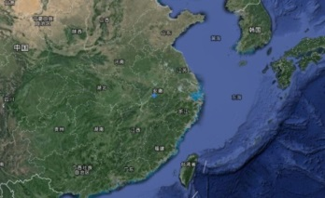
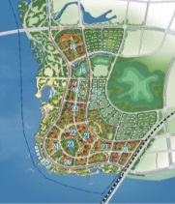
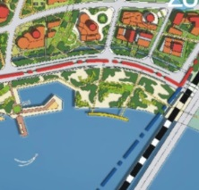
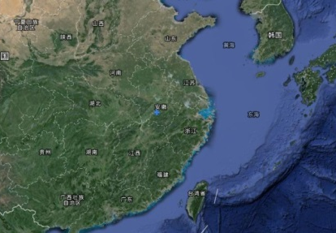
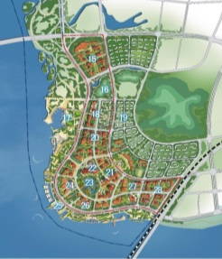
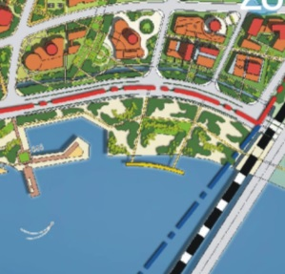

Fig. 1 Project location

In the Quanzhou Bay area, the Luoyang River bears special contents and meanings: Firstly, as the main one river of Quanzhou City, Luoyang River bears the historical humanistic connotation, the development of the city is built along the river; Secondly, as an important resource of the river in Quanzhou Bay region, Luoyang River carries the connotation of natural ecology, provides important strategic direction of the new city construction.[1] Meanwhile, the planning area is located at the intersection of the Luoyang River and the Taiwan Strait, it is an important window to set up the city image and display the regional style and features(Fig. 2). Therefore, the purpose of this study is how to achieve harmony with the urban landscape group in the design of waterfront landscape, at the same time with difference and strengthens the place of the region.
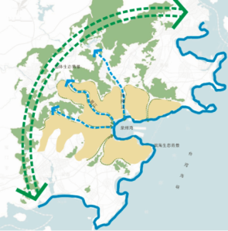
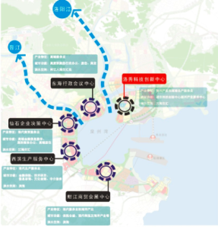

Fig. 2 Urban Structure and Ecological Pattern of Quanzhou Bay

II. Theoretical analysis

A. The concept of Placeness

Placeness: The sensory structure of a place formed by a person's experience in a particular environment, such as the excited emotion - excitement, joy, or pleasure.[2] Specifically contains two aspects of meaning:
- Place attachment, people's sense of place, sense of belonging and identity.
- Place identity, the characteristics of the place itself, the concentrated expression contains a series of features. These features endow certain places with certain emotions or personalities. Some places are regarded as a special or memorable place because of its unique physical characteristics or imaginability of, or is due and important events.
"Placeness" is one of the most important spatial characteristics of urban public areas, which should be maintained. The continuity and development of place is the most important point in the design of urban public space.

B. PPS——“Placemaking”

The "PPS"(The Prdject for Public Space) set up in 1975 suggests that in contemporary urban design, special attention should be paid to the participation and dialogue of citizens on the transformation of public space projects. In 2000, the organization proposes several key factors for creating a "good place"(Fig. 3), and use "Placemaking" to describe the design process of urban public space. [3]
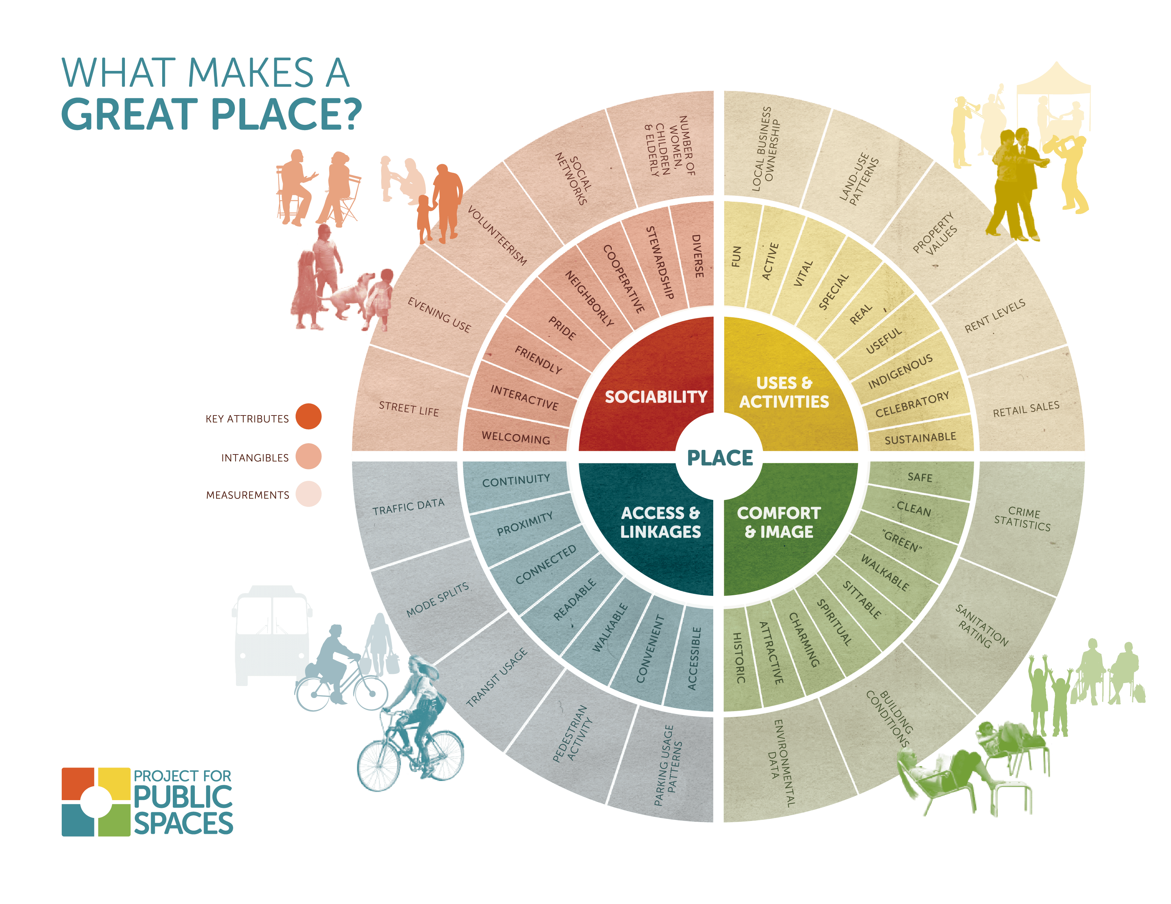

Fig. 3 What makes a great place?

Professor Guo Enzhang, a Chinese scholar, summed up a set of evaluation standards for the quality of urban sites in the design strategy of high quality urban public space, he believes that high quality city places should have ten characteristics. (TABLE I) In 2004, the standard was included by City Planning Data Set compiled by the China urban planning and Design Institute.[4]

TABLE I
FEATURES OF HIGH QUALITY CITY PREMISES

Identity | It is characterized by individuality and easy to identify
Sociality | Publicity and sharing for the public
Amenity | The environment pressure is small, the body and mind is relaxed, comfortable
Accessibility | Traffic is convenient, which can be expected and access to
Safety | Walking environment, no car interference, no line of sight, there’s lighting at night
Enjoyment | It has visual interest, beautiful environment and sanitation
Concordance | Whole coordination, orderly
Variety | The function and the form is flexible, rich and colorful
Culture | It has cultural taste and is conducive to the construction of civilization
Ecology | Respect nature, respect history, protect ecology

A material environment with placeness may bring positive image to urban public space, become an attractive place for investors, travelers and residents alike. Meanwhile, a good public environment can encourage and restore public confidence.

III. Related case study

Based on theoretical cognition of place, through the analysis of 4 related cases(TABLE II—V), this paper provides reference for the site design of Quanzhou Bay Pier Park. Case screening is based on the following aspects:
- Waterfront development drives urban development;
- The place of waterfront landscape upgrading;
- Effective control of urban waterfront public space and reasonable organization of internal traffic.

TABLE II
CASE-1 SANKT PETERBURG, NEVA RIVER

Summary | St Petersburg is located in the Baltic Sea east of Finland Bay with the Neva River and its tributaries throughout. It's the second largest city in Russia, an important industrial center and transportation hub. The river bank is the cradle of the city's rise. In the early development of St Petersburg port, it takes the image in front of the world, becoming the basis for the development of the entire city.[5]
Picture | 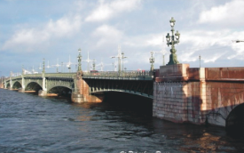  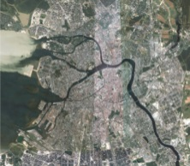
Feature | The waterfront landscape of this basin is the carrier of the beautiful scenery in the center of the city. For example, there are 8 bridges in this region, with each one has a complex structure of the building, and the shape is carefully designed, each bridge can become an outstanding work of Art.
Revelation | Using historical culture to develop characteristic waterfront area is beneficial to create unique urban landscape.

TABLE III
CASE-2 MANHATTAN BIG-U

Summary | BIG-U is a replicable modular system that can help coastal cities cope with climate change crisis. Facing the arrival of super hurricane Sandy, The protective landscape envisioned by the landscape design team will activate the urban waterfront instead of cutting off the links between cities and water. The project's public participation framework gives community residents an opportunity to find them, set up infrastructure that promotes local society and economic development, add the diversity of its adjacent coastal communities.[6]
Picture | 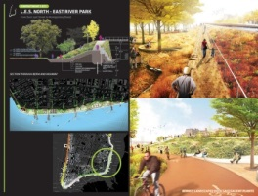  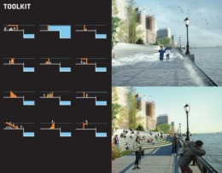
Feature | 1. The wetlands and the rain garden extends from the waterfront to the highlands of the green corridor and social housing in the open space will promote the local ecological diversity, improve local water quality, so as to minimize the overflow water directly to the East River pipe, and slow down urban heat island effect.  2. The new commercial space under the urban expressway will create new retail space and bring new business opportunities;  3. Community led functional planning contributes to the stability of communities and benefits for local residents.
Revelation | Brief and direct natural procedure to deal with problems caused by natural processes, bold design breaks the inertia of thinking limit.

TABLE IV
CASE-3 SHANGHAI HUANGPU RIVER BUND REGION

Summary | Before the planning, the landscape space along the Shanghai River in the Bund is separated from the Huangpu River by the road and the negative greening, making it lack of interaction. Meanwhile, the activity of waterfront area is relatively single, mainly ramble, the space of rest, entertainment is insufficient, lack of activity to attract local residents.[7]
Picture | 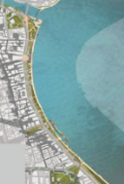  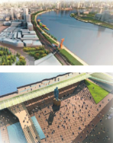  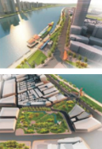  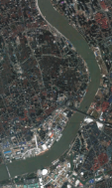
Feature | - This design uses different elevation platforms and squares as the focus of the whole environment of waterfront area, forming rich and abundant sequence of public activity space.  - As the main means of spatial linkage in this area, ramps provide safe activity paths and a rich viewing experience.  - Later design focuses on the better display of the restoration of the Bund's historical and cultural features, improve the ecological environment in the Bund, and create the most classic waterfront city landscape in Shanghai.
Revelation | The reasonable and effective use of the original landscape, organizational waterfront space node can enhance the overall image of waterfront environment, and create a variety of continuous space and service facilities to strengthen the living space.

TABLE V
CASE-4 NINGBO ECOLOGICAL CORRIDOR

Summary | Ningbo is located in the southern part of the Yangtze River Delta ecological region. Since ancient times, the river is vast and wide, and the vast land is occupied by riparian forests, reed marshes and farmland. However, under the pressure of high speed urbanization development, the canal ecological corridor region has been transferred for industrial use. At the same time, there is lack of effective zoning and pollution control, All sorts of factors together lead to the deterioration of water quality at the end of twentieth Century. Wetland and aquatic habitats is of great significance to the ecological zone, Therefore, it is not only in line with the ecological consciousness of the new era, but also of historical and cultural significance to do the best to intervene the wetland according to the regional characteristics.[8]
Picture | 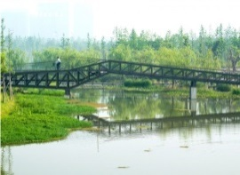  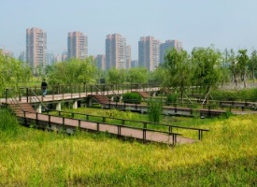
Feature | Reshaping the relationship between man and nature: The park design and road system planning make it become a model of natural succession in city environment. Ecological swamp, rain garden, aquatic plants garden and location of a restored habitat all have been carefully thought. Trestle road along cliff, stepping stones, bridges and louvers allow people to go deep into it and provide the possibility of close observation without affecting the growth of animals and plants.
Revelation | The stretching park allow countless people enter it and enjoy nature, the design looks like nature itself. The material of the bridge and road echoes the precipitation of the past industrial history, and at the same time, it isn’t lofty in the park.

Based on the theoretical basis of place, according to the above case analysis, six characteristics of the waterfront landscape places are summarized as following:
- Overall consideration and overall consideration can achieve the purpose of sustainable development.
- Waterfront area should have a clear positioning, and closely linked with the overall development goals of the city.
- The vitality of the waterfront area need participation in public life.
- The design of waterfront landscape should reflect the historical, cultural and geographical features.
- We should create composite waterfront environment including ecological protection, tourism, leisure and other needs.
- Attention should be paid to the organization of waterfront traffic system and the creation of public space, as well as the development of the waterfront landscape node.

IV. Concept of placeness in Quanzhou Bay Wharf Park

Used to be a wharf, the location of Planning area of the case provides a boost for local development, but with the city in the process, the scene of the past has ceased to exist. Based on six characteristics of waterfront landscape environment design, in the design of this case, the form elements with wharf features are utilized to create a place atmosphere to awaken people's Association——Stacked containers, staggered boardwalk, link this place with its history, how it used to be used, and its symbolism. (TABLE VI)

TABLE VI
ANALYSIS OF QUANZHOU BAY WHARF PARK

Spatial structure analysis
Summary | According to the characteristics of waterfront landscape design, land layout and functional requirements, the planning area is designed into 5 types of space: Service space, green space, distribution space, tourist space, hydrophilic space. 4 vertical and 3 horizontal walking roads are connected in different types of spaces, which form a rich and varied spatial hierarchy, and ensure the accessibility of each part in the region.
Master plan | 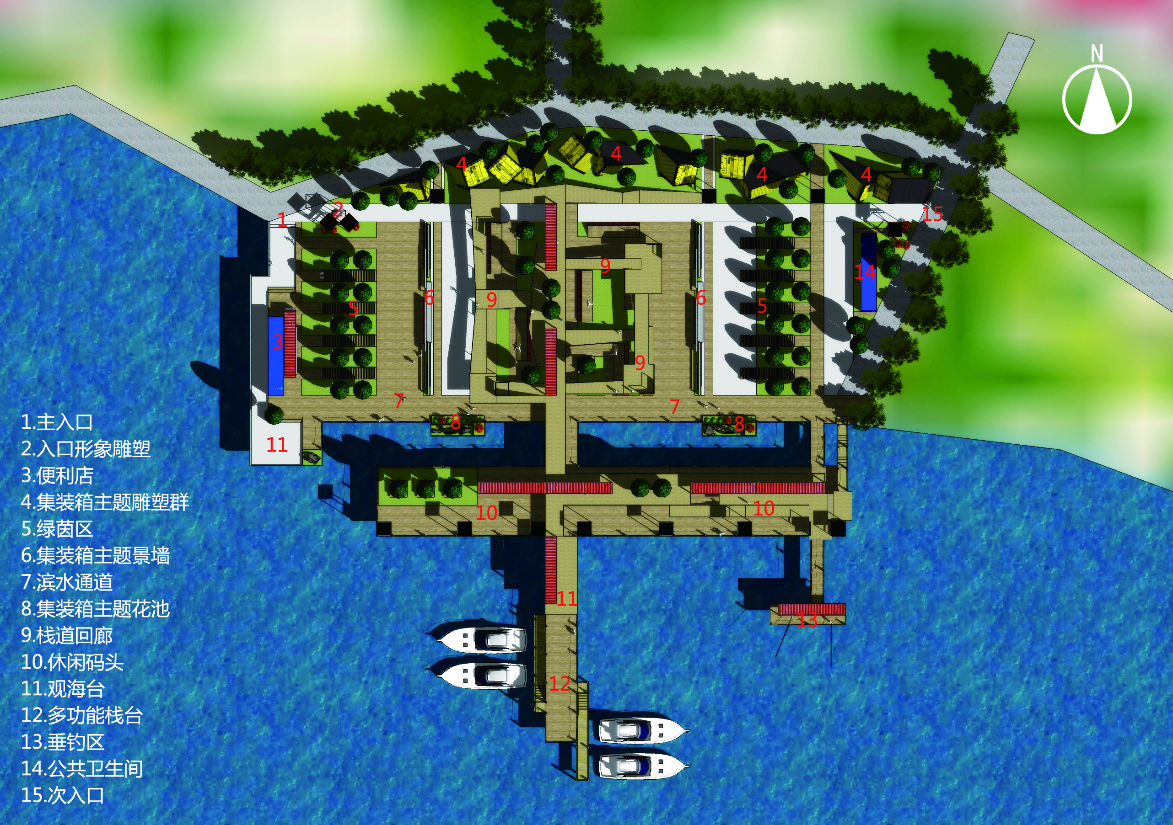
Analysis | 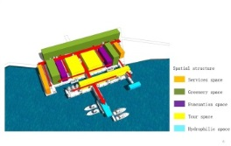  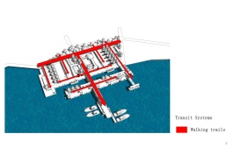  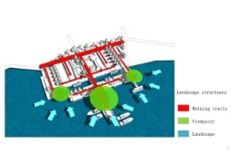  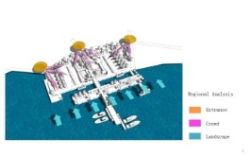
Landscape form analysis
Summary | In the landscape design of Quanzhou Bay Pier Park, express the status in the time development context of "History - Present - Future" in this region with the aid of this element of "container". For example, "container sculpture" shows the once prosperous wharf scene, or reuse the abandoned containers and transform them into convenience stores, landscape kiosks, and public toilet. Moreover, in the design of seat, street lamp, garden landscape facilities etc., the use of container elements is also taken into full consideration, so as to protect the unique spirit of place in the region, and the corresponding multi dimension space function.
Analysis | 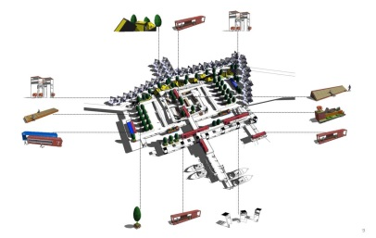  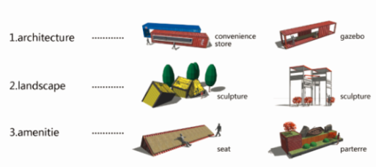
Landscape node analysis
Summary | In order to make waterfront space rich and diverse, each type of space contains a number of landscape nodes, and take on a different look, which represents a coastal based function.  - Winding corridor: Taking “wooden plank road” as design element, combining the principle of barrier free design, build a brand new tour route, create a continuous experience in leading into the water, and set up open space for visitors to stay at the turning point of the key route.  - Trestle work: Parking the boat, connect people with water through leisure activities.  - Wharf: It is made up of spacious waterfront channels and old container landscape pavilions to meet people's needs for viewing and fishing.  - Square: Different texture of the ground pavement echoes people's walking activities, the surrounding trees provide shade.
Renderings | 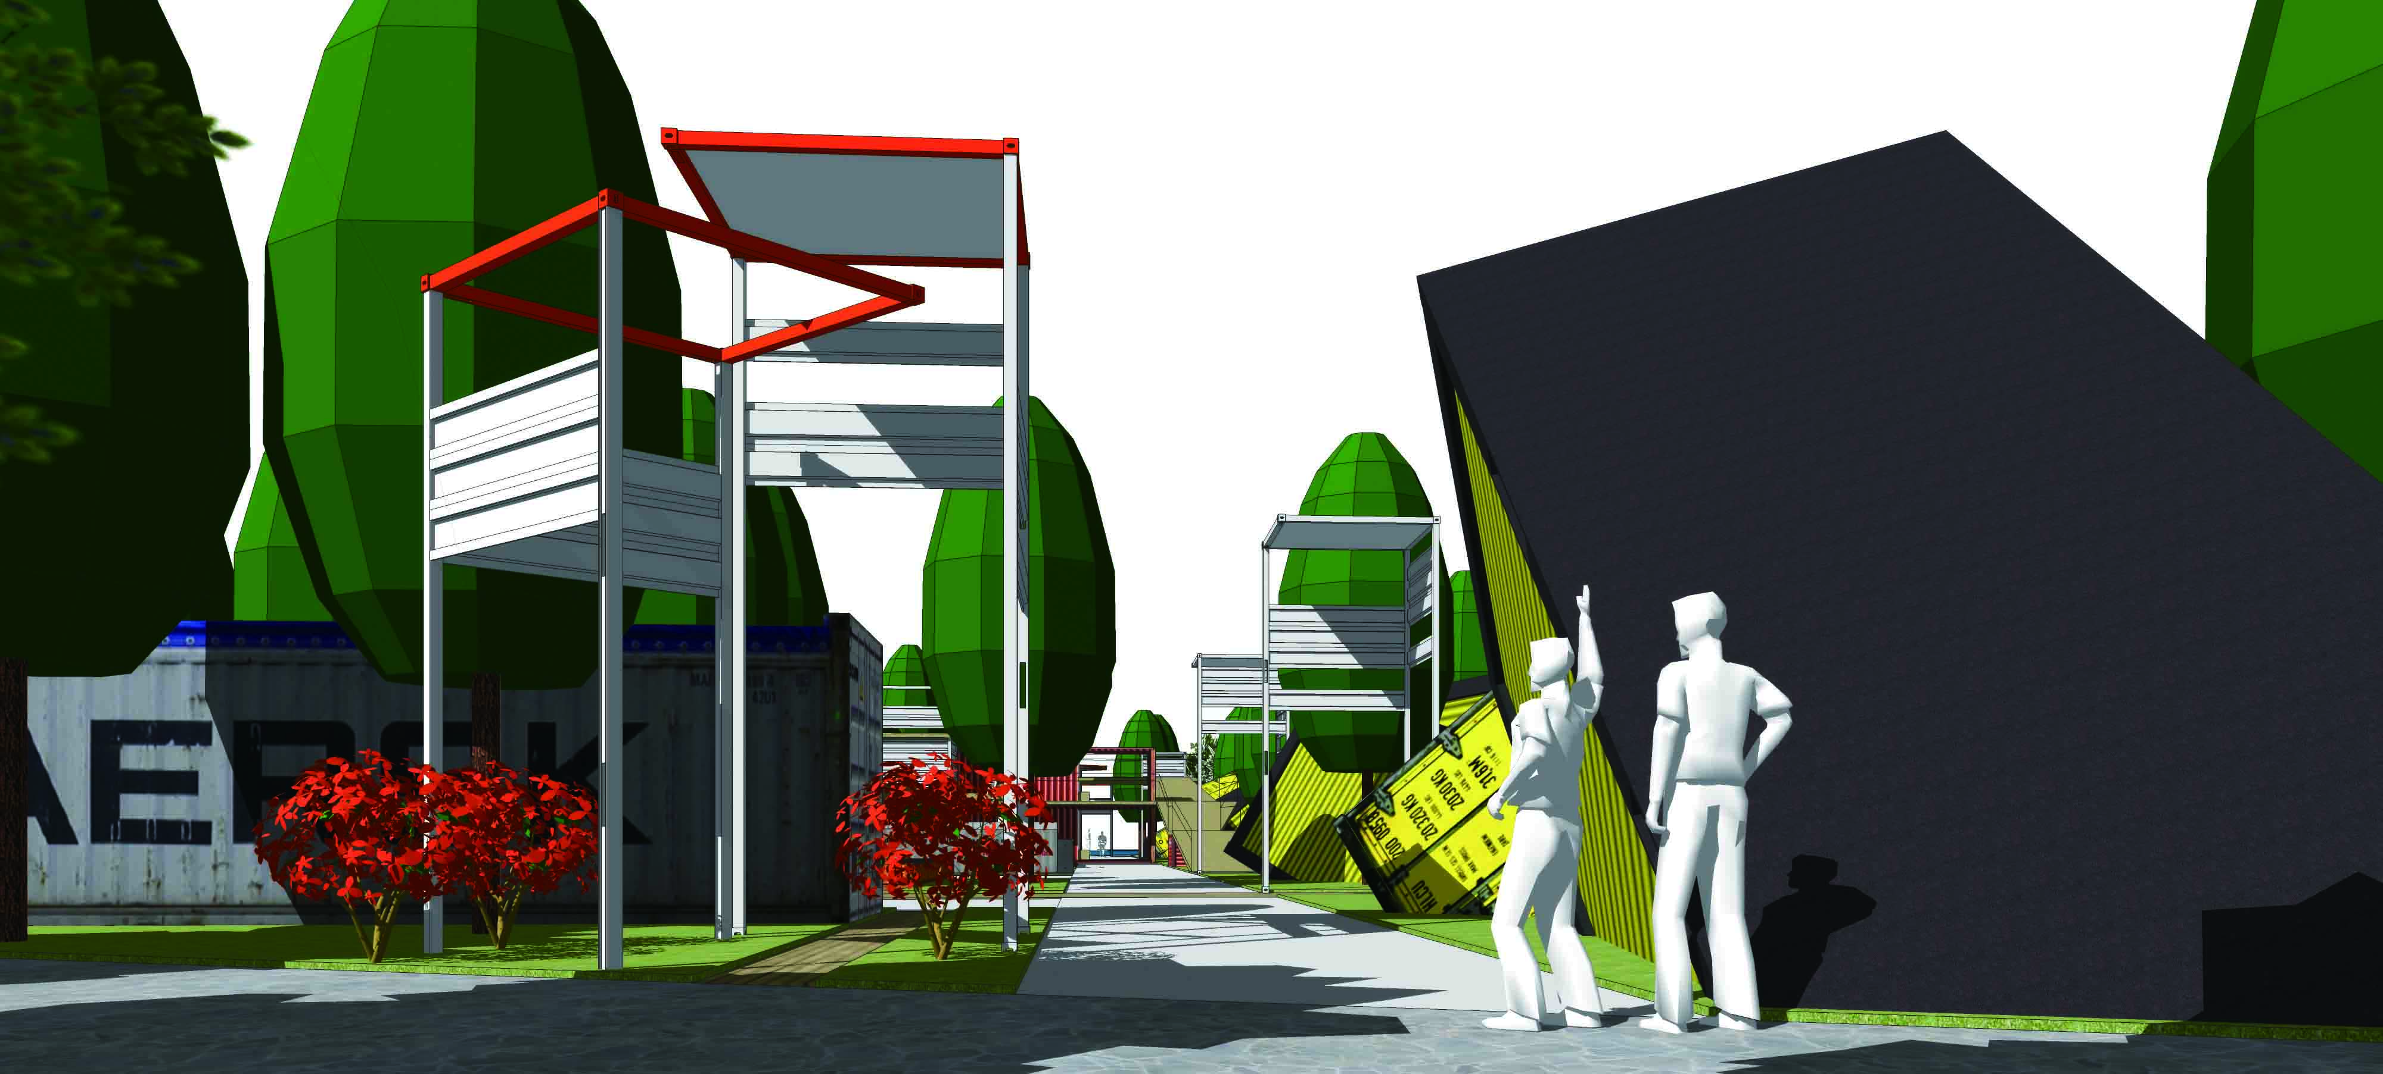  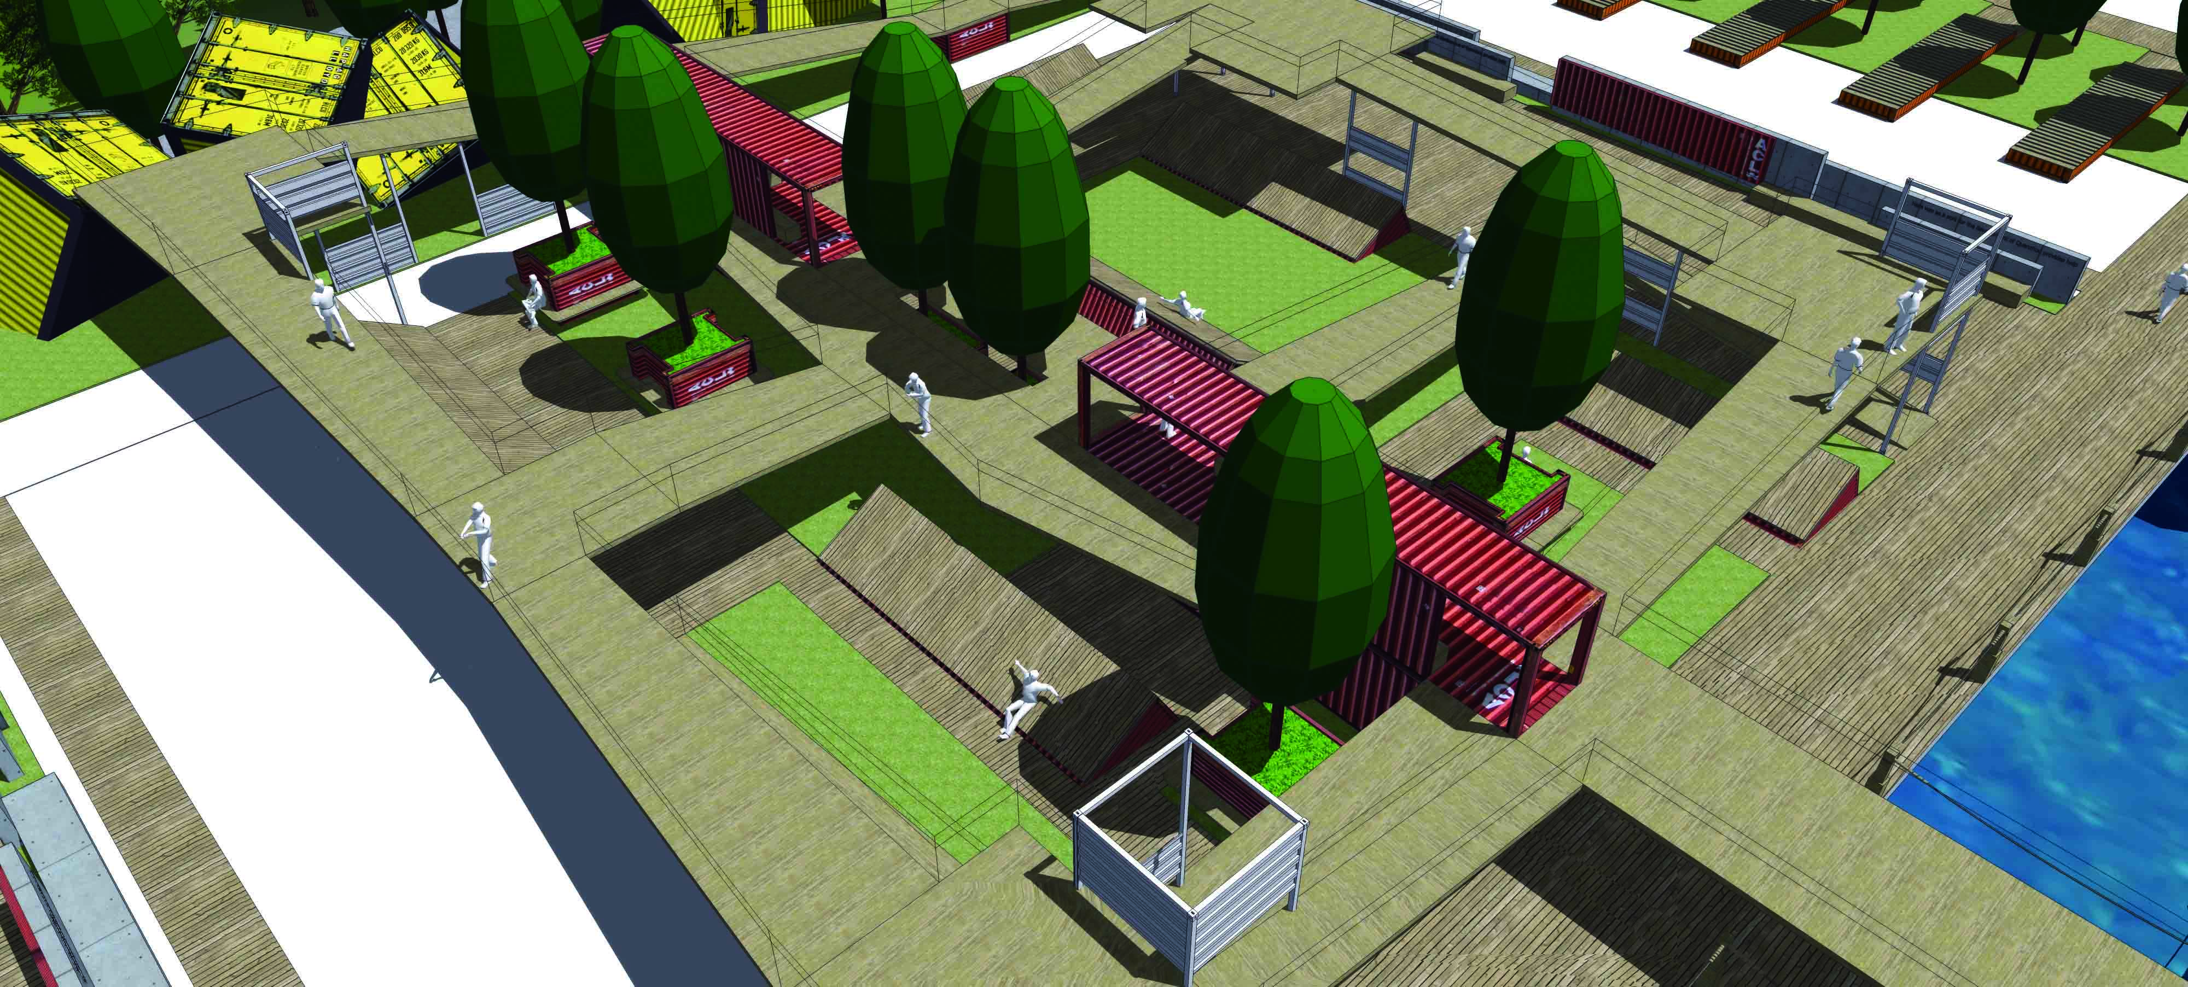  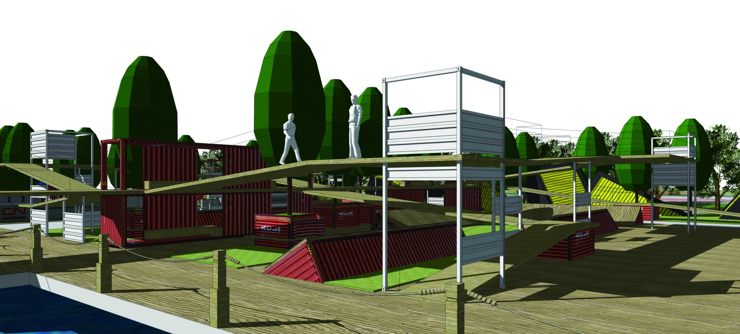  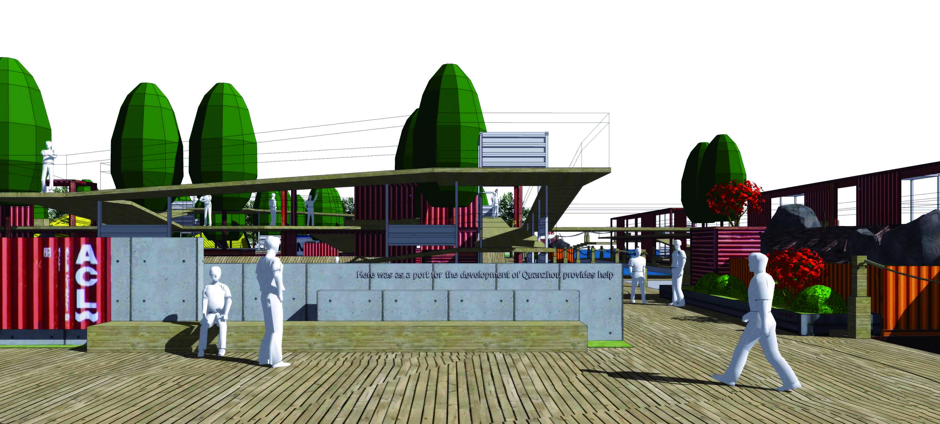  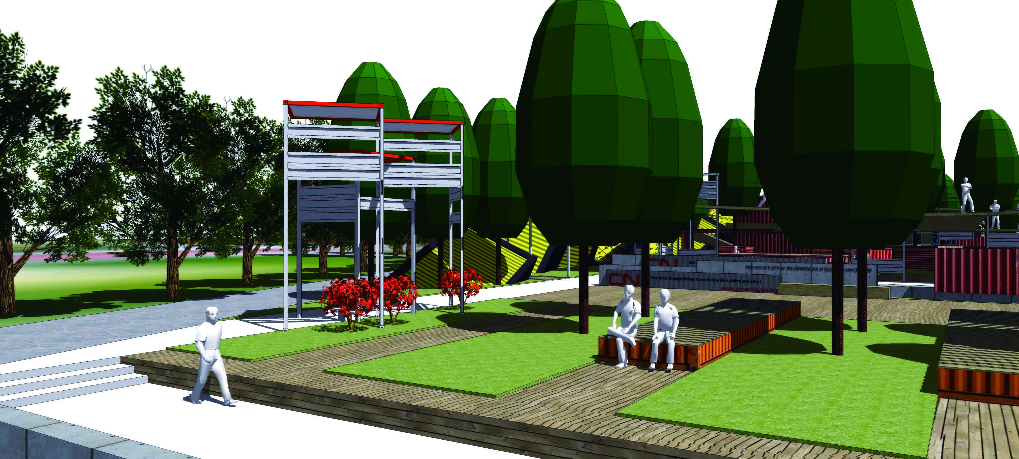  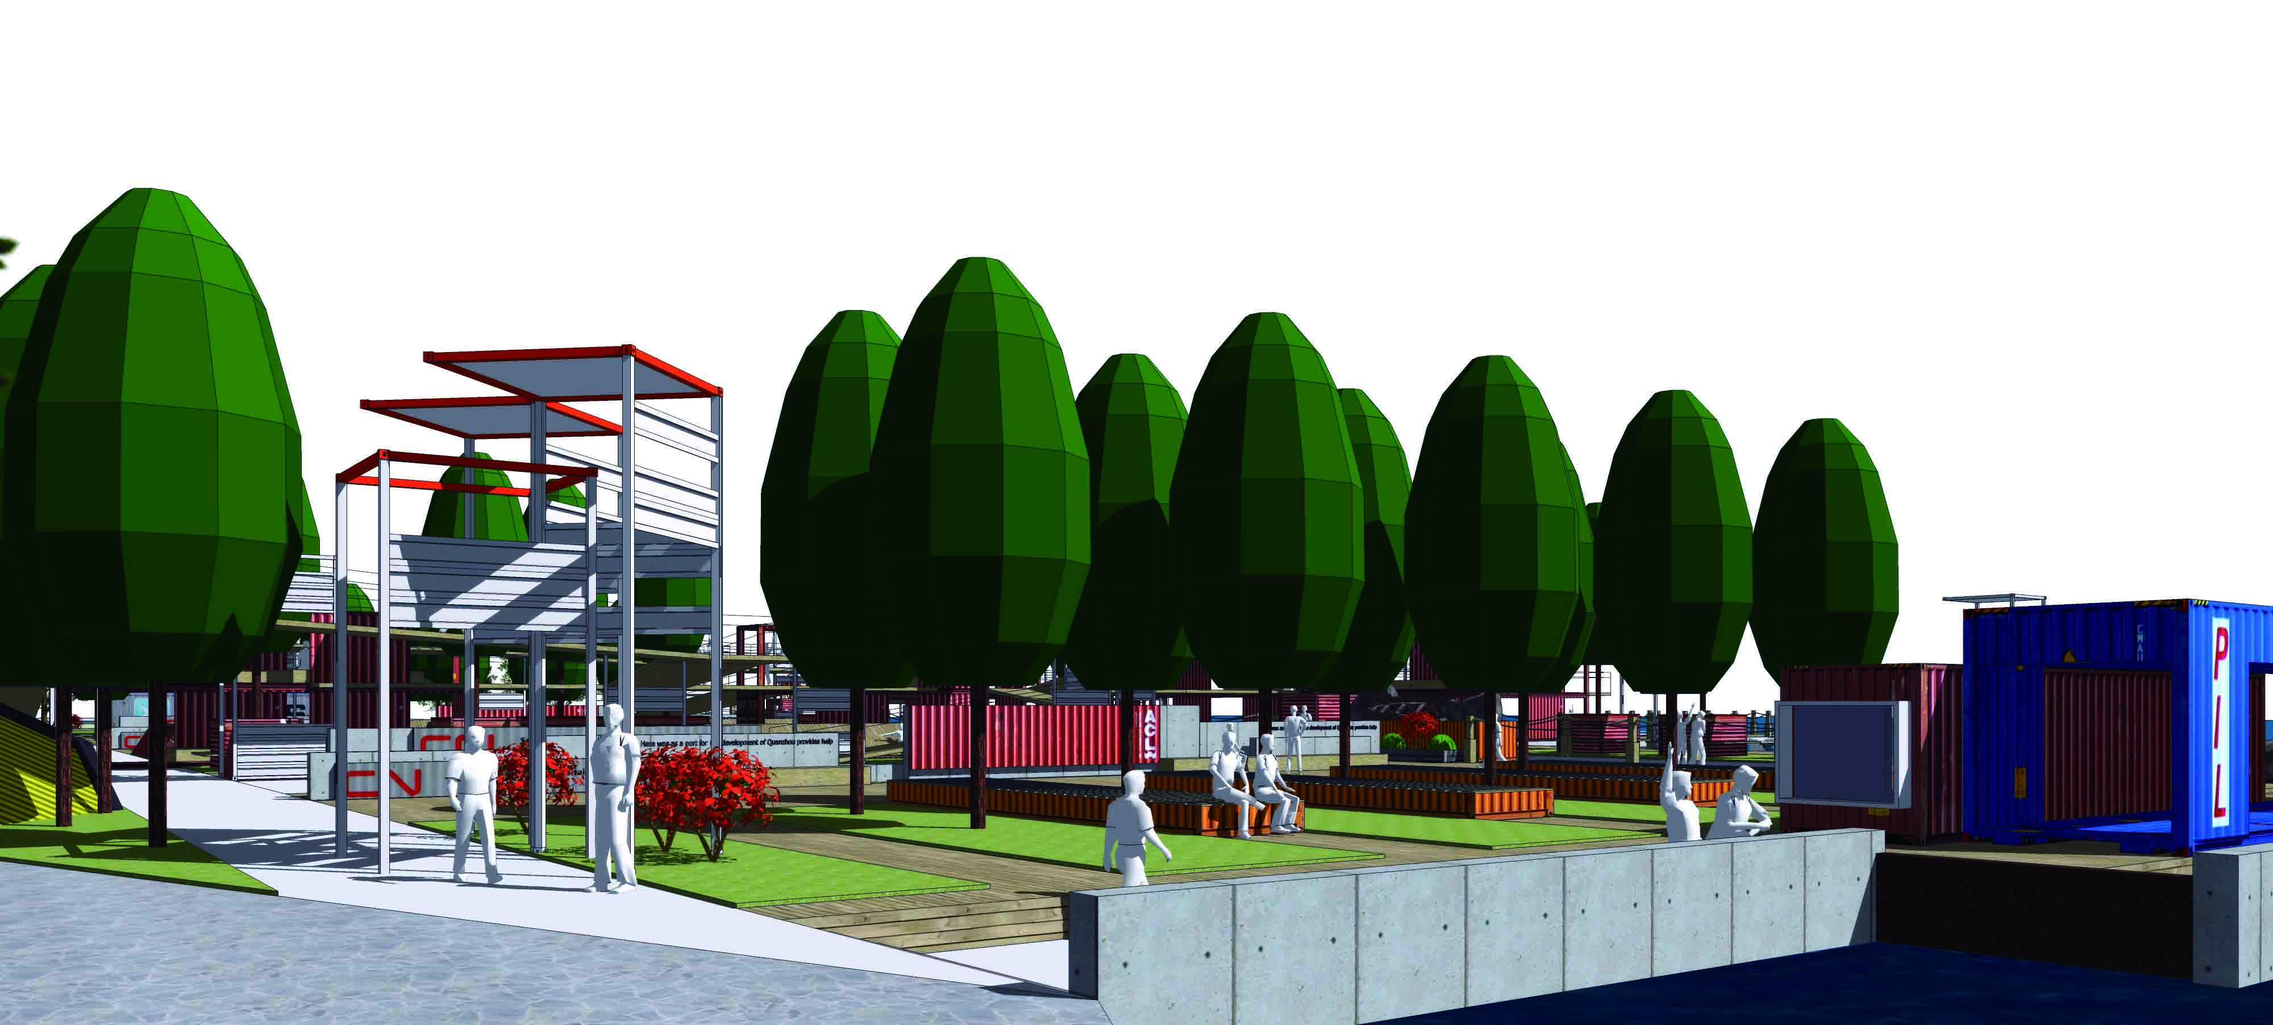
V. Epilogue

Successful urban public areas are not accidental, there must be suitable conditions. Through the integration of these conditions can promote the city regional activities and space, create a place of city environment. The book City Building: Nine Planning Principles for the Twenty-First Century points out that: The environmental content to be planned should be regarded as the result of the change of the surrounding conditions and functional requirements under the control of the limited conditions.[9] In the landscape design of Quanzhou Bay Pier Park, the location of the site, the development requirements of urbanization is the limit of the design. By protecting or creating a unique and memorable atmosphere of the environment, enrich people's behavior while strengthening environmental place, is the functional requirements that the design strives to solve.
Urban waterfront public area is not only a material structure, but also a social structure. This social structure is the embodiment of "human activities"——The behavior in the region is permeated by the way of life and activity, which makes the region full of vitality and vitality. Quanzhou Bay Pier Park creates a brand new trail system with Container plank road as design element, providing uninterrupted walking experience for park visitors. Moreover, the different functions and shapes of waterfront space highlight the participation of waterfront activities, provides help to promoting the regional vitality, materializing urban characteristics.

Acknowledgment

This research was supported by BK21 plus Level-up Project for Marine design team in Dongseo University.

References

[1] Quanzhou Municipal Government, Quanzhou CBD Investment Zone Master Plan 2010 Edition, 2010.
- M. Carmona, The Dimensions of Urban Design, Science and Technology Press, 2009, p.181.
- https://www.pps.org/reference/grplacefeat/
- China urban planning and Design Institute, City Planning Data Set, vol. V, 2014, p.95.
- L. Dotti, “St. Petersburg Neva River,'' Upban Planning Forum, vol. 30, 2009, pp.46-51.
- http://www.gooood.hk/2016-asla-rebuild-by-design-the-big-u-by-starr-whitehouse-landscape-architects-and-planners.htm
- M. Zhongjun, “Planning of Shanghai Huangpu River Waterfront Development,'' Upban Planning Forum, vol. 36, 2010, p.33.
- http://www.gooood.hk/2016-asla-general-design-awards-eco-corridor-resurrects-former-brownfield-by-swa.htm
- Philip Enquist, City Building: Nine Planning Principles for the Twenty-First Century, Jiangsu Press, 2013, p. 53.

